

57TH ANNUAL MEETING
57th Annual Meeting
April 2, 2022

KEYSTONE CREDIT UNION BOARD OF DIRECTORS
BARRY PATTERSON…………………CHAIRMAN OF THE BOARD
SERVING 1997-2022

JASON ROMANS…………………………………...BOARD MEMBER
SERVING 2020-2021

MICHAEL PETERSON……………………………...BOARD MEMBER
SERVING 2014-2021

JOHN PRATER…………………………………………BOARD MEMBER
SERVING 1980-2022

KIMBERLY HALE……………………………………………. BOARD MEMBER
SERVING 2021

CATHY PARKER……………………………………….BOARD MEMBER
SERVING 2018-2021

CARL AUVIL……………………………………………BOARD MEMBER
SERVING 2018-2022
KEYSTONE CREDIT UNION STAFF
ANGELA POWERS……………………..………………………..…....PRESIDENT
MINNIE CRAVENS…………………..……….….……………. VICE PRESIDENT
MARK CHELF…………………………….…..….……. SENIOR LOAN OFFICER
ETHEL LIVINGSTON……..……………….….….………………. LOAN OFFICER
EDD CLARK…………………..……………...……………REAL ESTATE LENDER
LUANN MASSEY...…………..…….……....………. REAL ESTATE PROCESSOR
HANNAH NOWLAND…..………..……...…..…………………. ACCOUNTING
YOLANDA DURHAM………………..……..……..……COLLECTION OFFICER
KATRINA FLORA...….......................................…………………………. TELLER
PATTI MEYER………………………….…..….….…………….…...............TELLER
JESSIE STARR …………………………..……….....................................TELLER
JENNIFER CROUCH………………………………………………………..TELLER
TERRY NOWLAND…………………………………………………CONSULTANT

KEYSTONE CREDIT UNION
SERVICES

SAVINGS ACCOUNTS
ATM CARD

SPECIAL SAVINGS ACCOUNTS

SAFE DEPOSIT BOXES

CHECKING ACCOUNTS
VISA DEBIT CARDS

INTERNET BANKING
BILL PAY
MOBILE BANKING

DIRECT DEPOSIT SERVICES

PAYROLL DEDUCTION

ACH SERVICES

IRA ACCOUNTS

PERSONAL LOANS
NEW AND USED AUTOMOBILE
MOTORCYCLE / ATV
BOAT / JET SKI
MOTOR HOME
SIGNATURE LOANS
TERM LOANS
STOCK LOANS
FARM EQUIPMENT LOANS

VISA CREDIT CARDS

MORTGAGE LOANS
MOTGAGES
1ST LIEN HOME EQUITY

57TH ANNUAL MEETING
Keystone Credit Union
Saturday, April 2, 2022

CALL TO ORDER …………………………………BARRY PATTERSON

ACERTAIN QUORUM………………………………….JOHN PRATER
6 DRAWINGS

MINUTES OF LAST MEETING…………………...BARRY PATTERSON

REPORTS TO SHAREHOLDERS

DIRECTORS REPORT……………………………MICHAEL PETERSON
6 DRAWINGS

TREASURER……………………………………………JASON ROMANS

AUDIT COMMITTEE…………………………………….CARL AUVIL
6 DRAWINGS

CREDIT COMMITTEE………………………………..…CATHY PARKER

COMMENTS FROM THE MEMBERSHIP
6 DRAWINGS

REPORT FROM NOMINATING COMMITTEE FAYE PETTIGREW
KEVIN FOWLER
TERRY NOWLAND

ELECTION OF DIRECTORS
2 DRAWINGS

OTHER BUSINESS
3 DRAWINGS

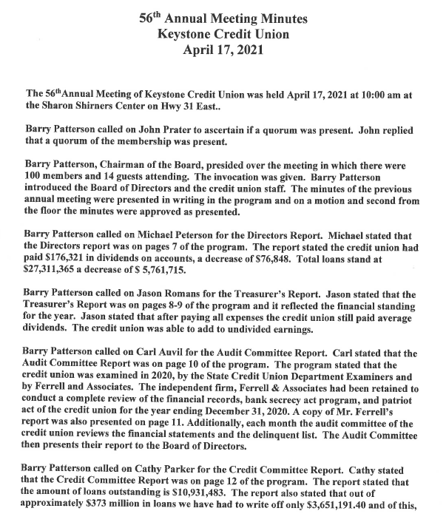

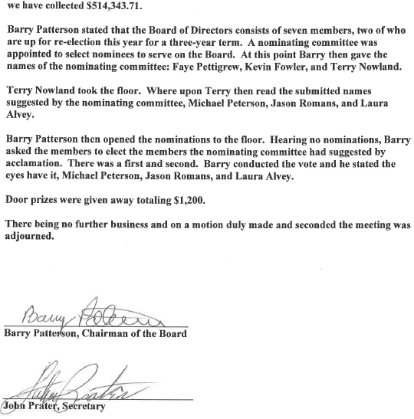
Directors Report

The Board of Directors consists of seven members whose names appear below. Directors meet each month in regular session and if necessary, call special meetings. The Board of Directors had one special meeting during 2021. Duties of Directors are to approve new members, to approve expense items, to approve loans to officials and directors and credit union employees, set up any special regulations or By-Laws, to set dividend rates and take care of any other business that comes before the board. These duties are performed on a voluntary basis without pay.
Our records indicate that we had a better than average year in 2021. Interest rates on certificates of deposit remained extremely low in 2021; therefore, we had to pay below our average dividend rates.
The credit union paid $131,951 in dividends on shares, deposit accounts, IRA accounts, and share draft accounts in 2021. This is a decrease of $44,370. The credit union’s loans stand at $25,453,227. This indicates that loans have decreased $1,858,138.
The Board of Directors would like to issue a special thanks to committee members, credit union personnel, and members for their continued support.

Carl Auvil Cathy Parker Barry Patterson
Michael Peterson Jason Romans John Prater
Kimberly Hale

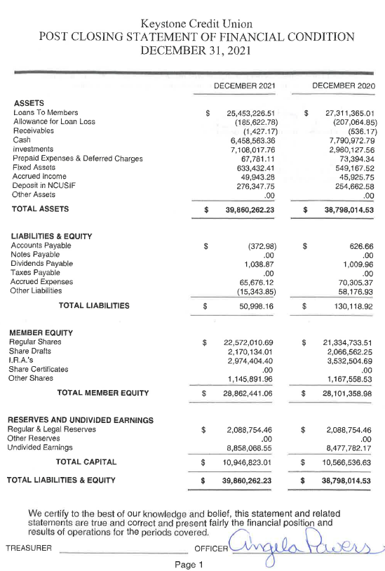

Audit Committee
Keystone Credit Union is examined by the state credit union Department examiners, the National Credit Union Administrators (Federal) examiners, and the Ferrell and Associates. The credit union is operated according to state rules and regulations. An independent auditing firm, Ferrell and Associates, has been retained to conduct a complete audit of the financial records of the credit union for the year ending December 31, 2021. A summary of this audit can be found on the next page. Additionally, each month the audit committee reviews the financial statement and delinquency list and presents its report to the Board of Directors. The review process includes a complete review of all delinquent loans, Bank Secrecy Act Program, Patriot Act, balance sheets, related statements of income, member equity, changes in financial position, and results of operation for the credit union for the past year ended December 31. 2021.
Based on the results of examination by the Texas State Credit Union Department, The National Credit Union Administration (NCUA), and Ferrell and Associates, the Audit Committee believes that the financial statements of the credit union present fairly the financial position and results of operation for the year ended December 31, 2021.
Management is to be commended for maintaining a financially sound credit union. The current success can be directly attributed to the dedicated people who serve in their various capacities.

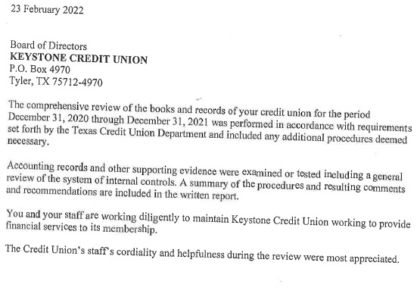

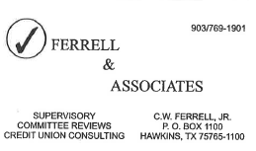

Credit Committee Report
The Credit Committee consists of five committee members who meet as needed to make decisions about perspectives loans. The Credit Committee many consider a members credit score, the value of collateral offered, length of employment, debt ratio, and other factors. The credit union does try to protect our Members’ money by making sound loans.
During the year 2021, the credit union made 578 loans in the amount of $11,812,098. Based on 52 weeks, the credit union averaged about 13 loans per week. Throughout our history, the credit union has made 145,305 loans for approximately $385 million. However, we have only had to write off $3,700,479.38; of this amount we have collected $523,719.64.
As of December 31, 2021, the credit union has $25,453,226.51 in outstanding loans. The credit union has loans for all of your personal needs.
As the above figures indicate, 2021 was an average year for the credit committee. We appreciate all of the committee’s efforts in making 2021 a successful year.

Mark Chelf Angela Powers Minnie Cravens
Yolanda Durham Ethel Livingston




